**EVNIRONMENTAL SETUP**

|  |  |
| --- | --- |
| **DATE** | **17 nov 2022** |
| **TEAM ID** | **PNT2022TMID34000** |
| **PROJECT NAME** | **CUSTOMER CARE REGISTRY** |

**FLASK SETUP:**

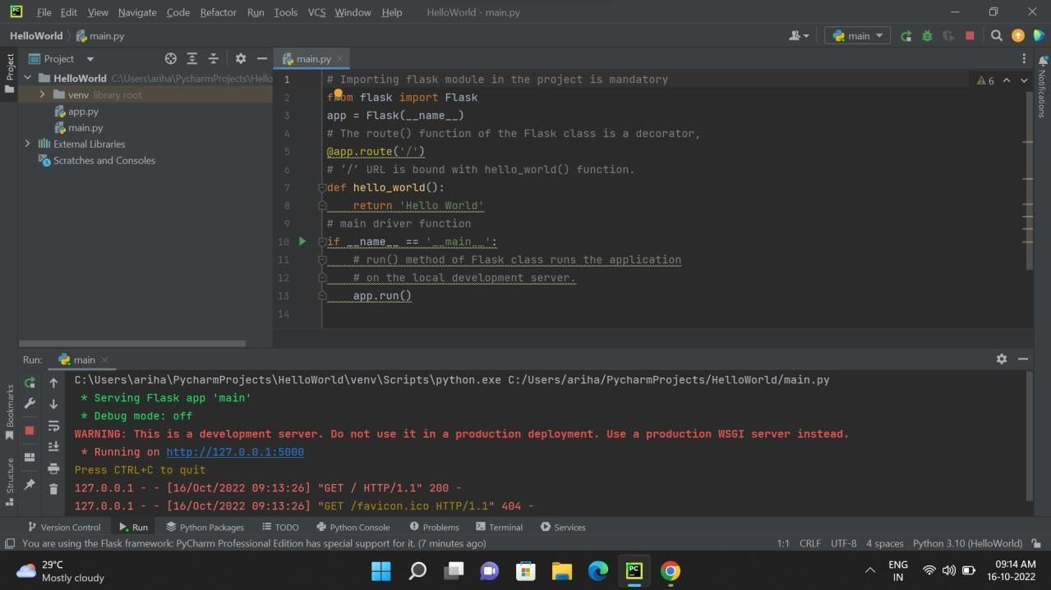

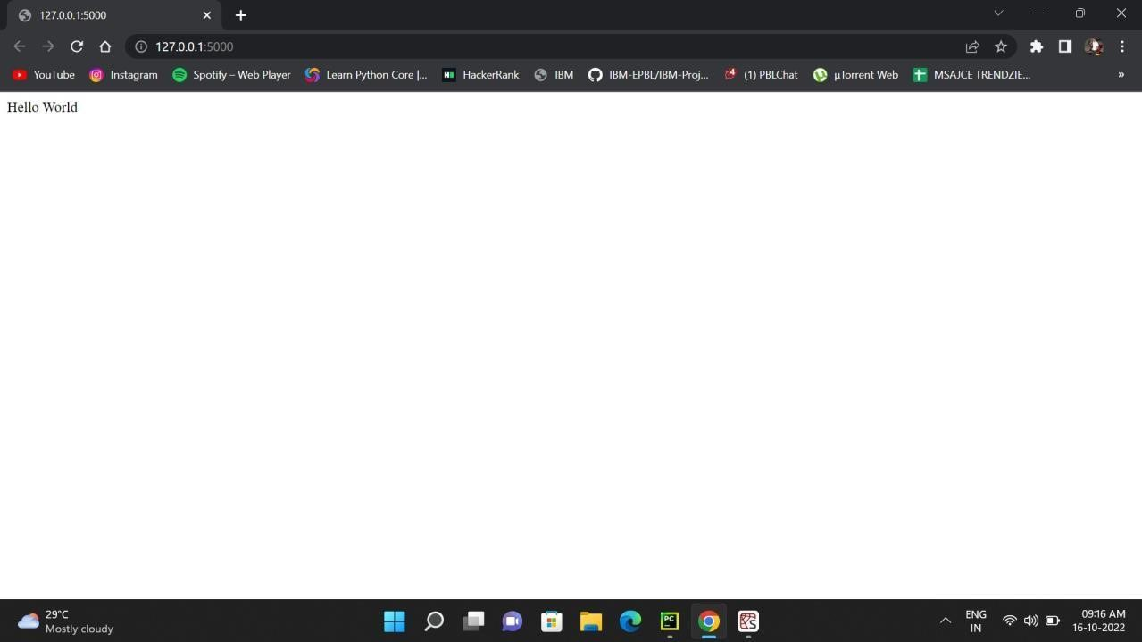

**DOCKER SETUP:**

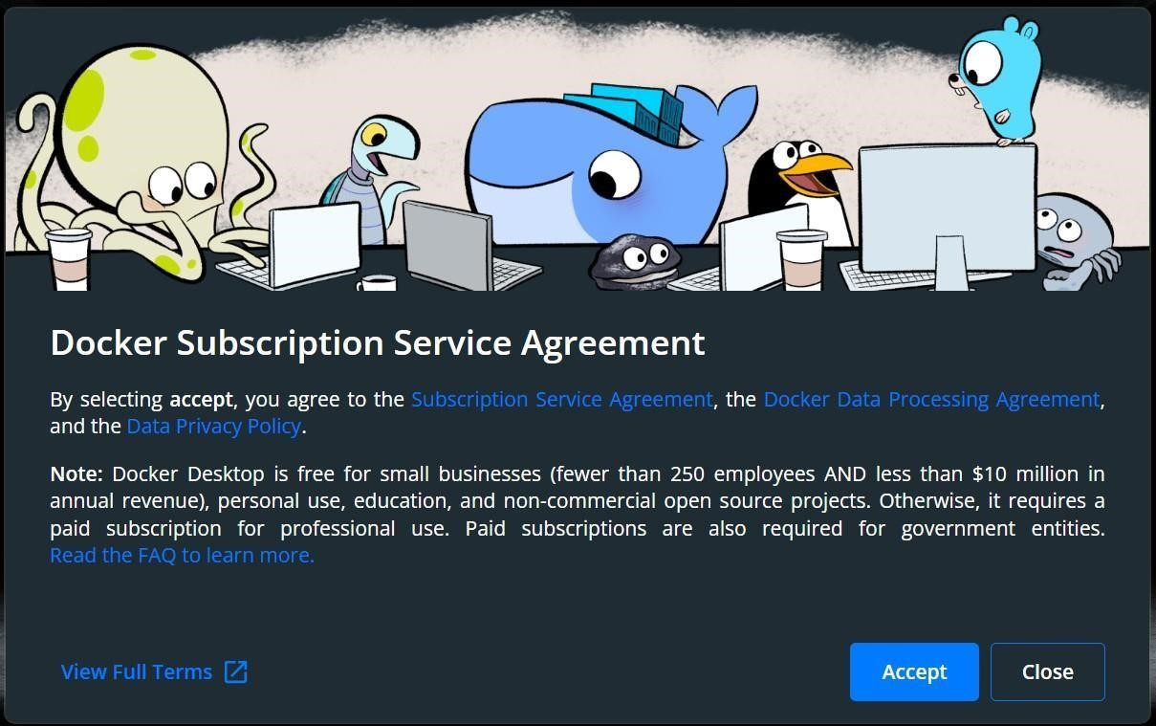

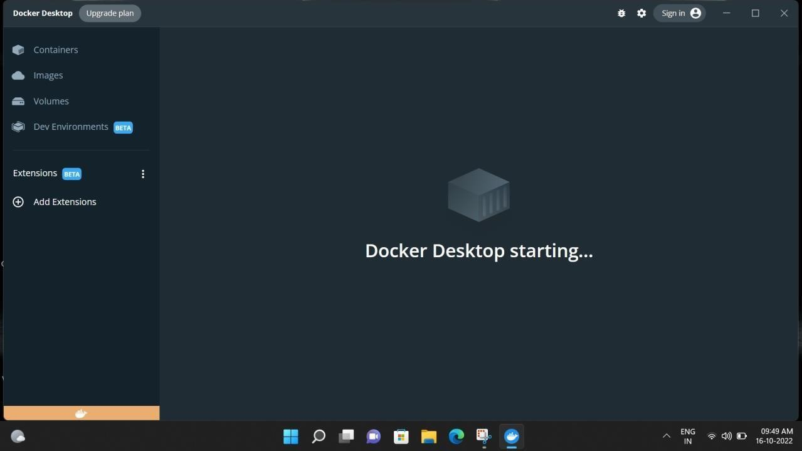

**COLUD ACCOUNT CREATION:**

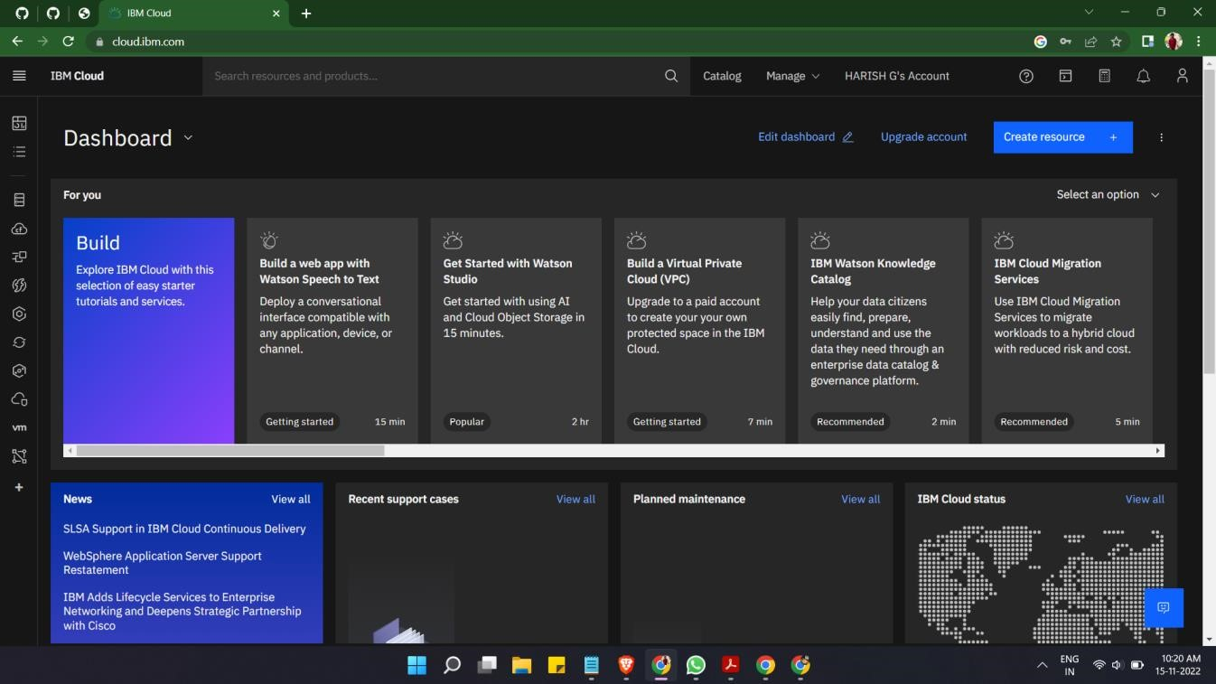

**SENDGRID ACCOUNT CREATION:**

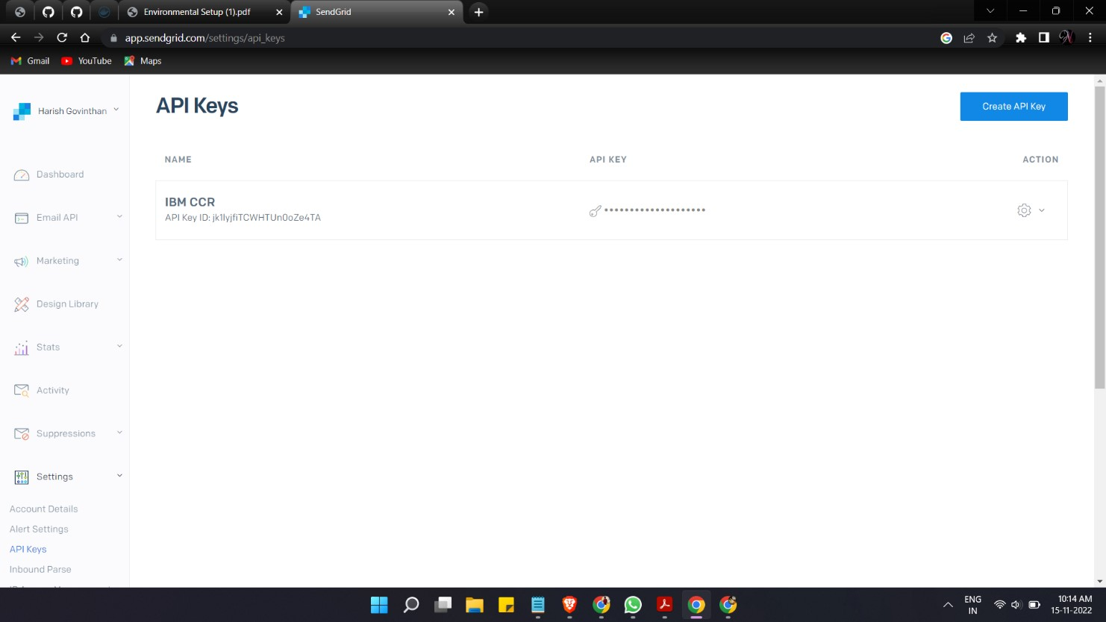

**IBM CLOUD CLI INSTALL:**

